From http://www.cs.columbia.edu/~junfeng/10sp-w4118/lectures/

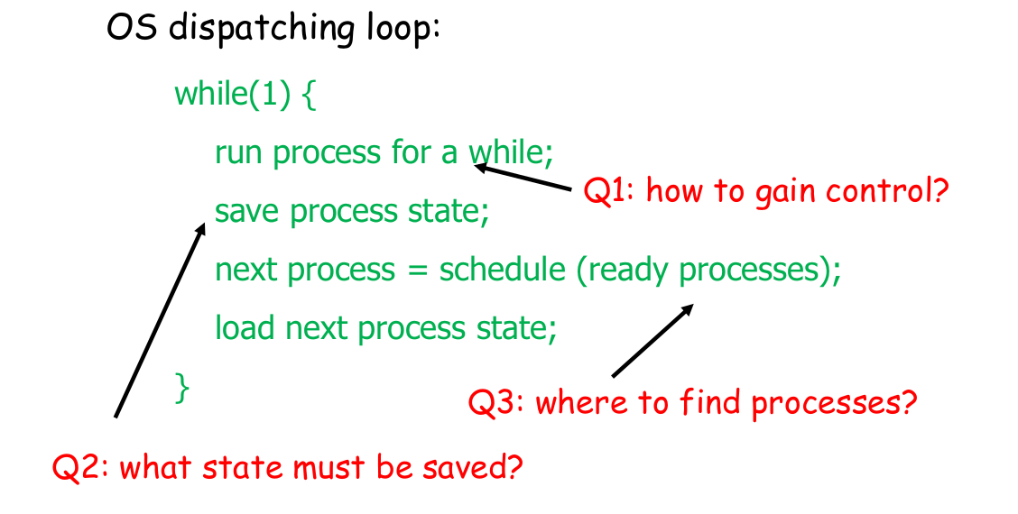

Interrupts (3 kinds)
- HW – signal from external device to processor
- SW – program generate system call (like write)
- trap – error (divide by 0)

How does a CPU respond to interrupts?
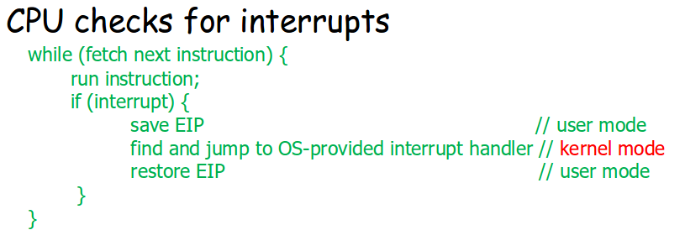

Note the transition to kernal mode
note entire machine instruction is executed!

OS sets up an interrupt descriptor table (IDT)at boot
lives in memory (HW knows its base)
Each entry is an interrupt handler (Interrupt Service Routine (ISR))
find handler by:
handler = IDT[intr_number]
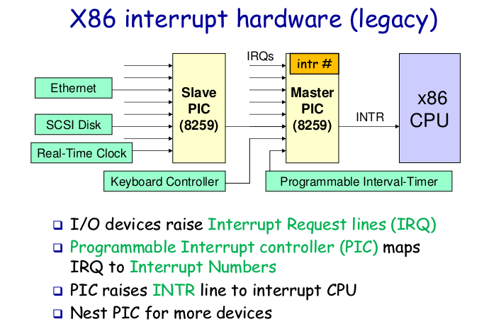
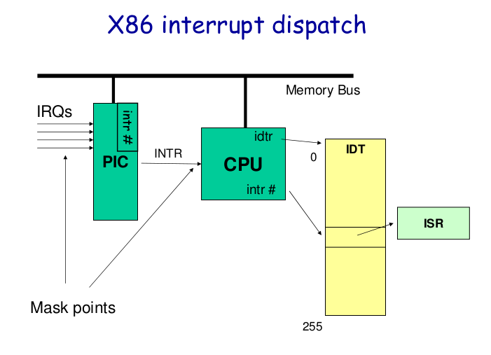

from http://faculty.salina.k-state.edu/tim/ossg/Introduction/OSworking.html
